TERMS OF REFERENCE

For Works Supervision Services

for the pavilion of the Republic of Serbia
for "Expo 2025 Osaka”

Section 1 – The Republic of Serbia’s Pavilion for EXPO 2025
Outline Development Brief

The Republic of Serbia’s Pavilion for EXPO 2025 - Outline Development Brief

Expo 2025 is an upcoming World Expo organised by the Bureau International des Expositions, which will be held in Osaka, Japan. It will take place for six months during 2025, opening 13 April 2025 and closing 13 October 2025.

Merging the theme of OSAKA EXPO 2025 – Designing Society for the Future (Society 5.0) and the concept of the EXPO 2027 BELGRADE – Play for humanity, Serbian pavilion will introduce the natural motifs of the heart of Serbia and universal language of play as a catalyst for connection, learning, creativity, and cultural exchange.

The Pavilion has a concept of FORTRESS OF CULTURE with the next few sub-themes:
PLAYGROUND
- LEARN & PLAY
This section focuses on playful learning experiences for families and children. It features a
landscape field with urban playground products, promoting outdoor games specific to
Serbian culture, such as "školice" and "lastiš." The design incorporates playful elements
that encourage interactive and educational activities.
- PLAY, EXPLORE & DISCOVER
Visitors engage with an interactive wall that serves as a play map. They can touch, move,
observe, and learn about the logic behind the pavilion's theme. This section also includes
an info booth where visitors can gather additional information and guidance.
- SHOP
This section recreates the atmosphere of a Serbian market, integrating design elements
and nature inspired by open markets around the world. It offers a social area with modular
elements where visitors can relax and enjoy the playful ambiance. The section includes a
public restaurant that captures the playful character and bohemian charm of Serbian
culture, providing both outdoor and indoor seating.
PAVILION
- THE ART OF PLAY - PLAYFORMANCE
This section serves as the entrance experience to the pavilion, featuring a mini art gallery
that showcases Serbian artistic expressions. It also includes a stage that represents the
vibrant performing arts scene in Serbia, providing a conceptual representation of a
performing spot.
- THE FAIR PLAY
This interactive exhibition area is designed as a sports arena, promoting fair play and
sportsmanship. It offers engaging activities and displays that encourage visitor
participation and interaction.
- PLAY, ENGAGE AND CONNECT
This multifunctional space serves as a social hub and networking area, suitable for hosting
forums, business meetings, and networking parties. It provides a dynamic environment for
interaction and collaboration among visitors and participants.
- PLAYFUL MINDS, PLAYFUL FUTURE
Similar to the previous section, this space functions as a conference area but also serves
as a venue for sharing activities, lectures, workshops, and similar events. It provides an
additional office space to facilitate collaborative work and knowledge exchange.
- PLAY FOR HUMANITY - INTRODUCTION TO
SERBIAN EXPO 2027
Experiential corridor and lobby before the final stage (restaurant) will introduce the concept
of the EXPO2027 BELGRADE.
- BAR / TERRACE
The area that summarizes all the experiences of the Serbian Pavilion in the terrace and
restaurant place with an open view towards the greater surrounding of EXPO, as well as
providing a comfortable leisure space for both relaxation and active events.

ARCHITECTURAL DESIGN
FLOATING ISLAND

Merging the theme of OSAKA EXPO 2025 – Designing Society for the Future (Society 5.0), this concept extracts the natural motifs of the heart of Serbia and introduces throughout architectural but also experiential context.

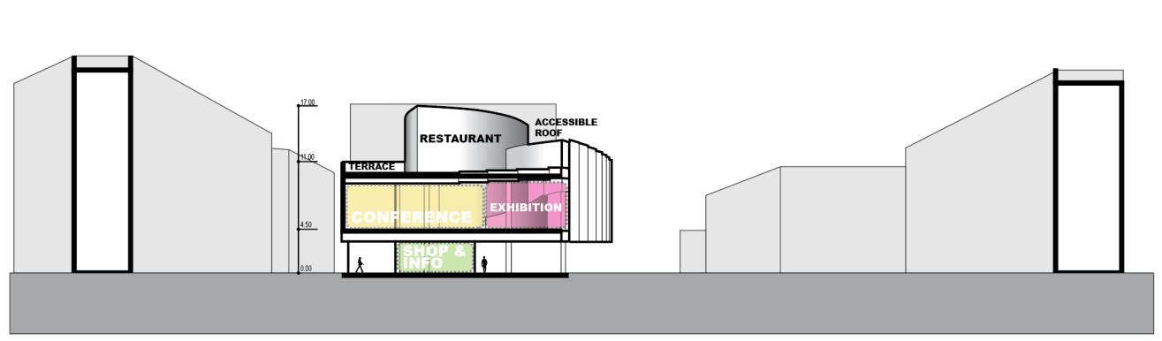
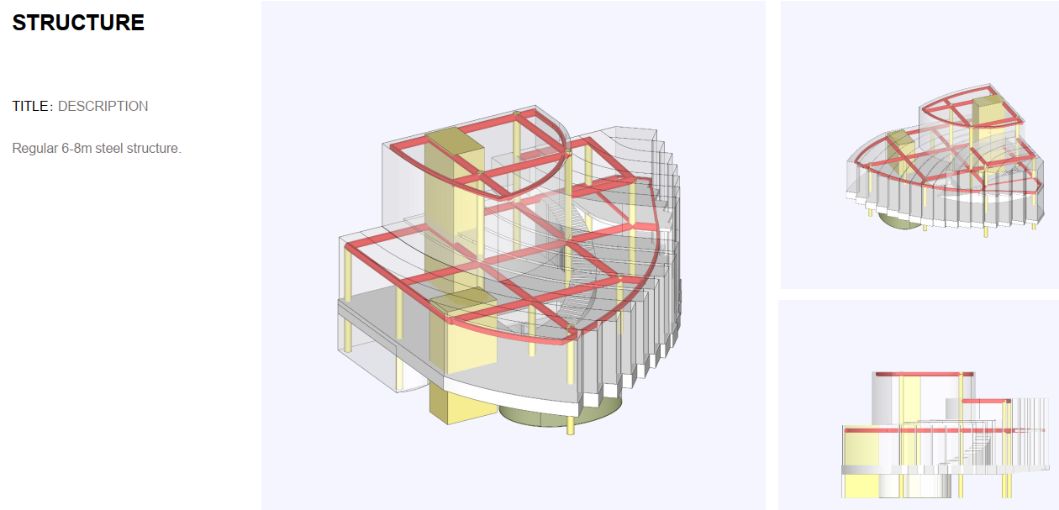

Section 2 – Scope of Services

5.1 Generally

5.1.1. This Scope of Services relates to the role of Works Supervisor (WS). All Services required to fulfil the Works Supervision role on a project of this nature shall be undertaken by the WS, whether expressly stated in this scope or not.

5.1.2. The Client will assume the role of Engineer under the Contract and will delegate duties as appropriate to the Works Supervisor to enable him to fulfil properly his scope.

5.1.3. The Works Supervisor shall prepare and issue to the Client a detailed Report by not later than 5 working days following the end of site visit and control. The Report should detail progress to date, Check lists, detailed quality report and forecast in the template required by Client.

5.1.4. The main language for communication will be English.

5.2 CONSTRUCTION PHASE

5.2.1. Quantity Control

5.2.1.1 Check quantities of works done and compare it with the planned quantities.

5.2.1.2. Identify any anticipated conflicts or delays. Advise the relevant contractors of such and develop a range of potential solutions to resolve conflicts or eliminate / mitigate delays.

5.2.1.3. Expedite the contractors to produce short term lookahead programmes and monitor progress against these schedules.

5.2.2. Quality Control

5.2.2.1. Monitor the work on site against the Project QA Plan and the approved contractors’ Quality Plans. Identify any non-compliances and expedite the contractors from making the required improvements in performance.

5.2.2.2. Manage the Design Team and Technical Supervisor to undertake regular inspections as specified in their contracts and communicate the results of the inspections to the contractors. Monitor the remedial works.

5.2.2.3. Expedite the Design Team and Technical Supervisor to witness any tests as determined in the Design Specifications. Ensure that accurate test records are taken and filed and that any remedial action is undertaken by the contractors.

5.2.3. Handover

5.2.3.1. The contractor is to produce punch lists prior to offering works to the Client’s team for inspection and monitor progress in clearing noted defects.

5.2.3.2. Works Supervisor is to undertake inspections of the works prior to taking over. Expedite sign off works following rectification of snags and defects.

5.2.3.3. Control the Contractor to ensure that all Tests on Completion are undertaken, witnessed, recorded and that the results are in line with the Performance Specifications in the Design. Control any remedial works required if Tests are not satisfactory.

5.2.3.4. Collecting all necessary documentation for review by the Works Inspection team.

5.4 POST CONSTRUCTION

5.4.1. Defects

5.4.1.1. Expedite the contractors to rectify latent defects that become apparent during the 6-month defects period following handover.

5.4.2. Commercial

5.22.1. Prepare and issue all certificates required by the Contract during the Defects period.

